Download this file then go to here.
Once there, select File/Open:
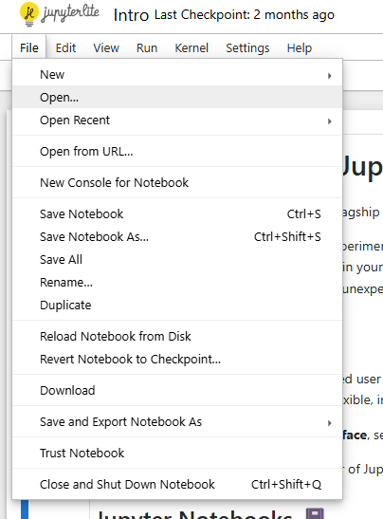
Then select "Upload" in the far right hand corner:
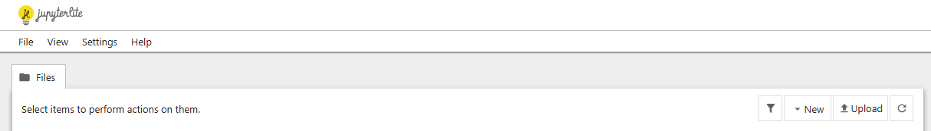
Next, find your file and click Open. You will then see this:
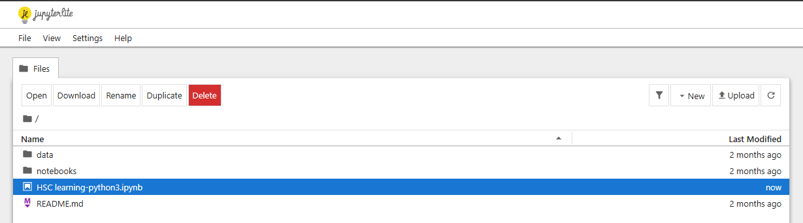
Double click on the file. You will then see this:
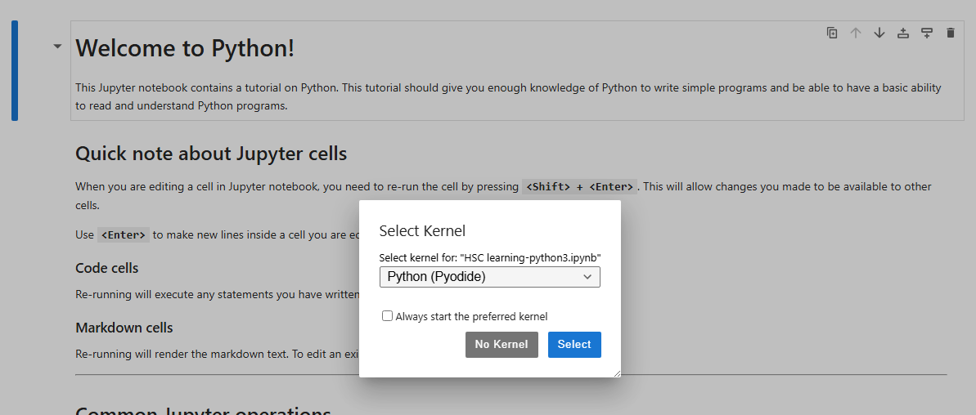
Click on Select.
To run Python code in a Python cell, click on the cell and click "Shift+Enter".

